COMP 126 Final Project Design Spec:

The main idea behind my website is just to have control over one singular platform through which I can share my projects, ideas, and really anything else that I want out in the world. The structure I used for this site is a bit unorthodox in that it technically has two home-pages. The INDEX.HTML page is more of an entrance to the site than it is a part of the site itself. It does not follow the same layout as the other pages, nor does it provide very many navigation options to the site. There is only one site linked to it (HOME.HTML) and the only way to get back to it once one has entered the main site is to click on the image in the footer. Because this website will likely contain a lot of my personal information, I like the idea that there’s a barrier in place between the site link and the main site itself (not that I expect it to offer much protection). I also think it will serve as a way to separate my website from traditional digital portfolios/personal blogs/ etc. and even though the site does not technically exist yet, I’m heavily amused by the idea that people will likely not be able to figure out how to navigate back to the INDEX page. It’s an inside joke, a resume, a portfolio, a blog, and a bunch of random stuff, and while it will not fully encompass every part of myself, my hope is that it will do better than what one of these could do alone.

I would like for the overall tone of my website to be exciting and fun, with just a splash of danger. I chose to use a warm-color based pallet in part because I personally like warm colors, but mostly because of how emotional they are. I did some research on the emotional side of color theory and found that while warm colors often evoke feelings of optimism, happiness. and energy, they should be used cautiously as they can also feel angry or aggressive. For this reason, I decided to use a more muted shade of yellow (the brightest and most obtrusive of the warm colors) and a deep dark purple (associated with creativity, but also because black is a bit too harsh) to balance out the bright red and orange. My intention when making this website was to try and incorporate as much of my personality into the design as possible. The font that was used throughout the site was created specifically for this website using samples from my handwriting. While I don’t write everything in all capital letters, I chose to use them for this font since that is generally my go-to style whenever I am doing something creative, such as sketching out the blueprints for a fun, new project. I do think that the choice of font takes away from some of the professionalism of a personal website, however, I myself tend to be about unprofessional as I can be without jeopardizing my job, so I think it works well.

LAYOUT:

Design Sketches:

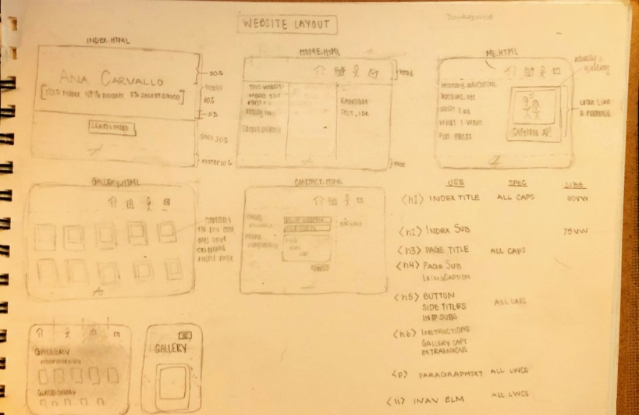

DesktopView:

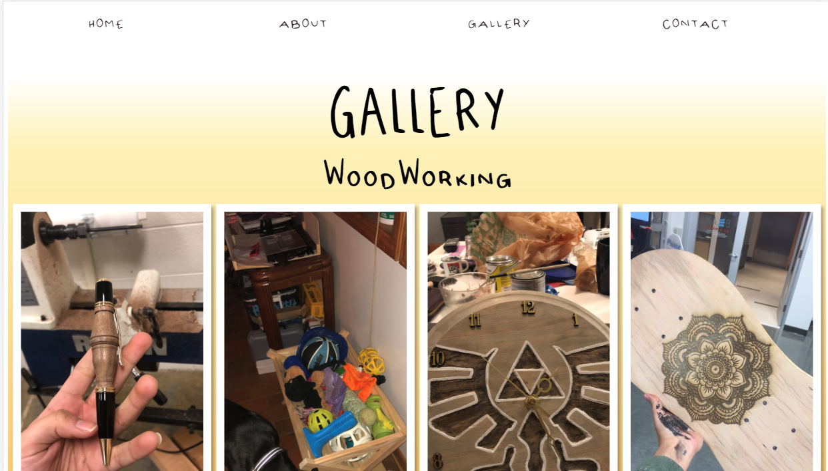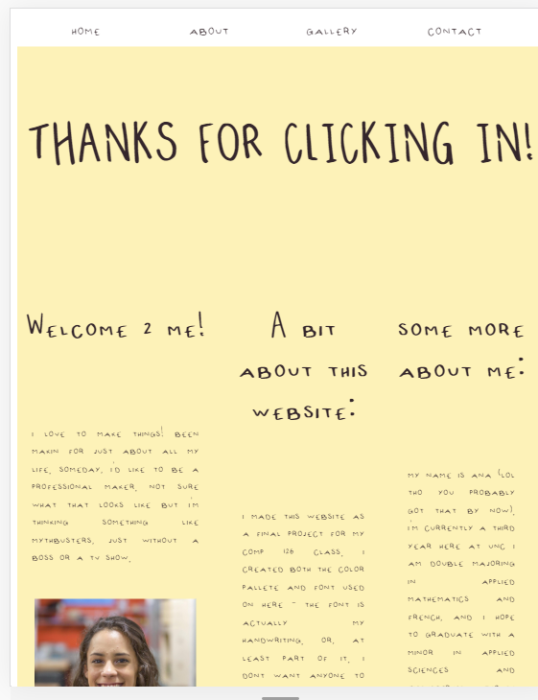

Mobile view:

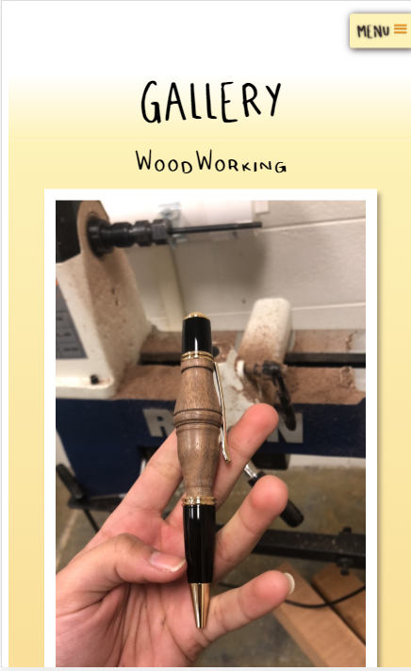 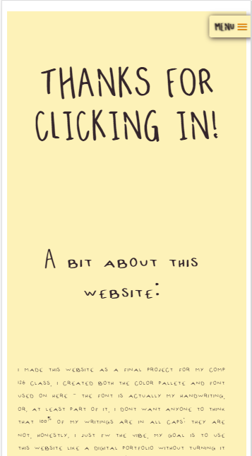

DESIGN PALETTE:

COLOR SCHEME: 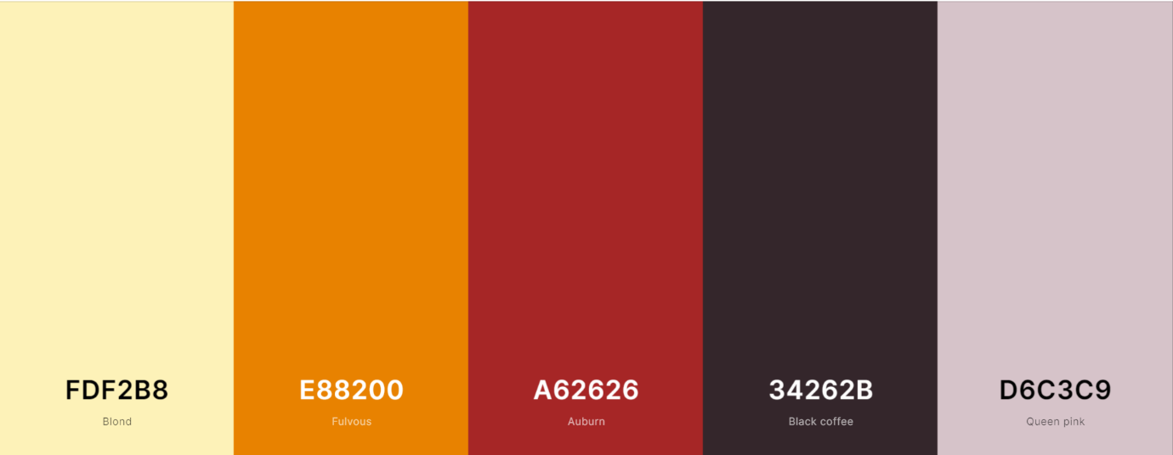

Used as main background | Used as accent color | Used for background /transition | Used for text and hovers | Used only in INDEX

FONT CHOICES:

The site was created using variants of one single font

|  |  |  |  |  |
| --- | --- | --- | --- | --- |
| ELEMENT | USAGE | STYLING | FONT SIZE | EXAMPLE |
| <h1> | INDEX.HTML TITLE | UPPERCASE, BOLDER | 20VH | **EXAMPLE** |
| <h2> | INDEX.HTML SUBTITLE | BOLD | 7VMAX | **Example** |
| <h3> | PAGE MAIN TITLE | UPPERCASE | 10VMAX | EXAMPLE |
| <h4> | PAGE SUBTITLE |  | 7VMAX | Example |
| <h5> | BUTTONS, ASIDE TITLES | LOWERCASE | 6VMAX | example |
| <p> | PARAGRAPH TEXT | LOWERCASE | 3VMAX | example |
| <figcaption> | GALLERY CAPTIONS | LOWERCASE | 3EM | example |
| <li> | NAV ELEMENTS | LOWERCASE | 4VMAX | example |

SITE EXAMPLES:

INDEX.HTML:

Main area regular:

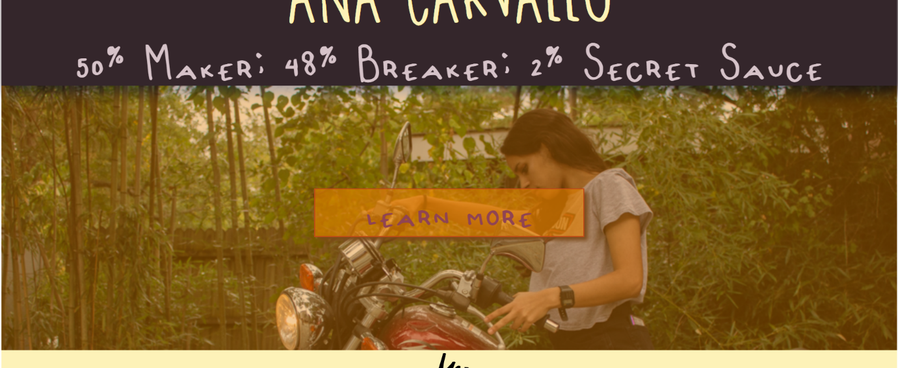

On hover :

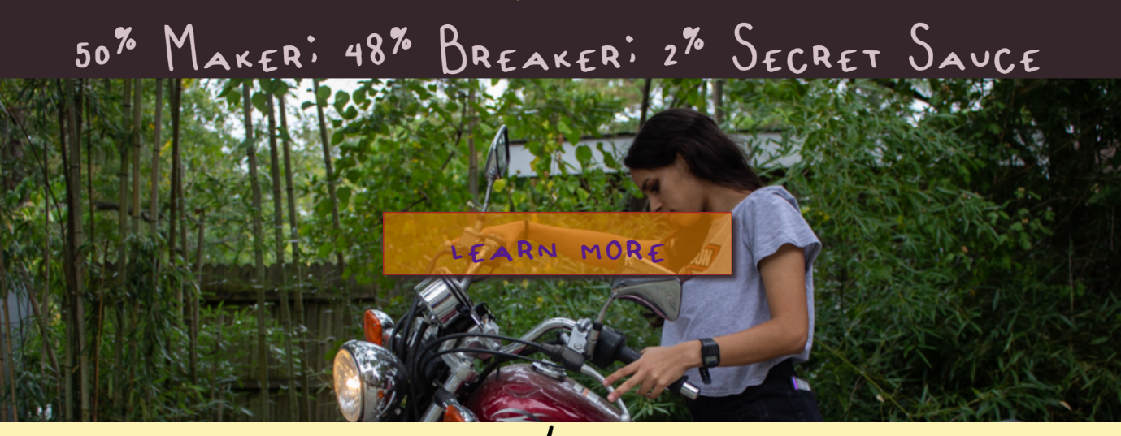

Button on hover:

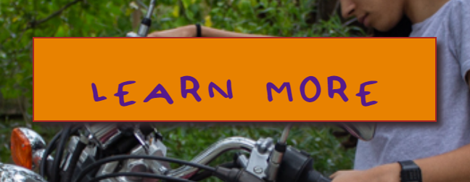

NavMenu on hover:



SlickNav on hover:



Gallery Image:

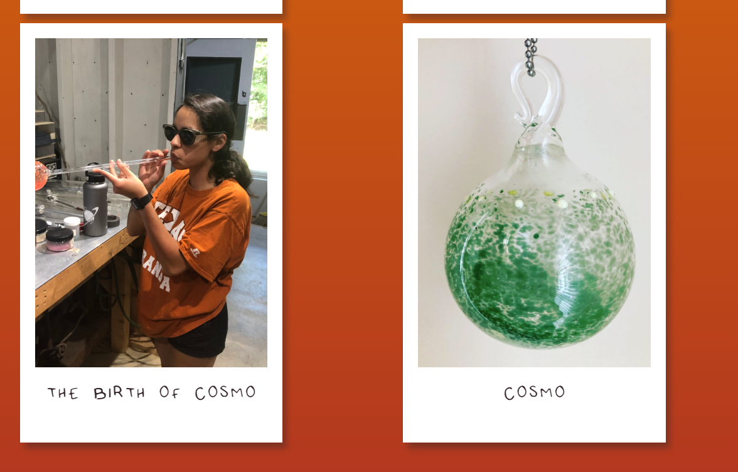

Gallery image on hover: Linked image on hover:

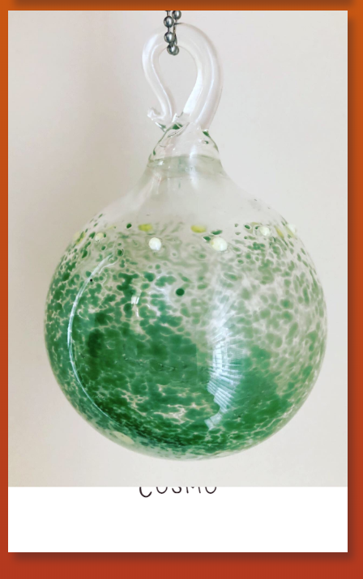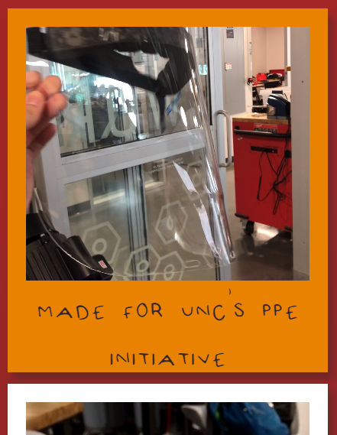

Homepage section on hover:

